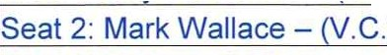
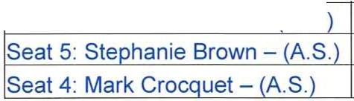
Academical Village
Seat 1: Ro Pressman - C.) Seat 3: Thomas Carlson - A.S.
Community Development District
Agenda

Wednesday March 2, 2022
11:00 a.m.
Nova Southeastern University, Campus Supporting Building
7501 S.W. 35th Street, Davie, Florida 33314 https://meet.goto.com/789415557
+1 (571) 317-3122; Access Code: 789-415-557

- Roll Call

- Approval of Minutes of the July 7, 2021 Meeting

- Consideration of Resolution #2022-02 Approving the Proposed Fiscal Year 2023 Budget and Setting the Public Hearing

- Ratification of Engagement Letter with Grau & Associates to perform the Audit for Fiscal Year Ending September 30, 2021

- Acceptance of Audit for Fiscal Year Ending September 30, 2021

- Discussion of Procedures for the Landowners - November 2, 2022

- Staff Reports
  - Attorney

  - Engineer

  - Manager

- Financial Reports
  - Approval of Summary of Invoices

  - Balance Sheet

- Supervisors Requests and Audience Comments

- Adjournment

Meetings are open to the public and may be continued to a time, date and place certain. For more information regarding this COD please visit the website: http://www.academicalcdd.com

